Tech mahendra

0.explan k8s architecture?

0.1 diff between docker vs k8s?

0.2 diff between container vs pods

1.kubernetes hpa ,wt command using scalling pods?

2.how to get pods ,wt is command

3.how to check namespace, k8s,wt is command

4.how to check pods in specific name space in k8s?

5.wt is etcd in k8s?

6.wt is deamonset vs statefull set in k8s?

7.wt is pv vs pvc in k8s?

8.wt is diff config map vs secrets?

9.error occurred while running container then how to edit app configaration file ?how to resolve it in k8s?

10.if we are getting container crashloop error in k8s? How to resolve it?

11.how to check listening port in server?

12.how to check memory of the server?

13.how to check specific file in server?

14.how to copy file from one server to another?

15.how to login private server, which gate ur using in aws?

16.wt is diff eip vs public ip?

17.how to attach docker volume to container?wt is command

18.wt is ingress load balancer vs load balancer in k8s?

1. explan k8s architecture?

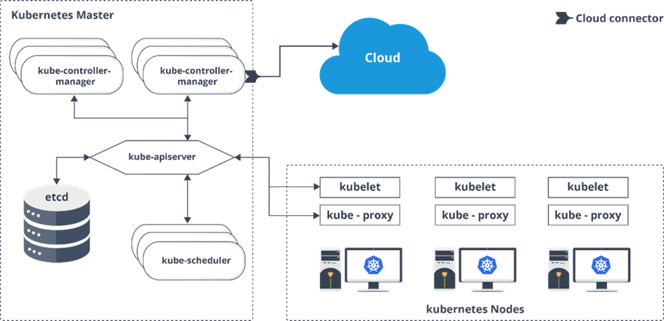

<https://k21academy.com/docker-kubernetes/kubernetes-architecture-components-overview-for-beginners/#:~:text=Kubernetes%20architecture%20follows%20a%20distributed,the%20operations%20across%20worker%20nodes>.

2. diff between docker vs k8s?

While Docker is a container runtime, Kubernetes is a platform for running and managing containers from many container runtimes. Kubernetes supports numerous container runtimes including Docker, containerd, CRI-O, and any implementation of the Kubernetes CRI (Container Runtime Interface)

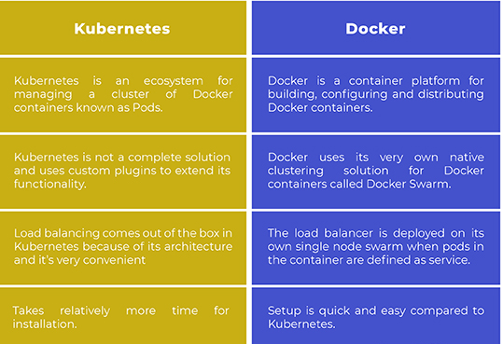

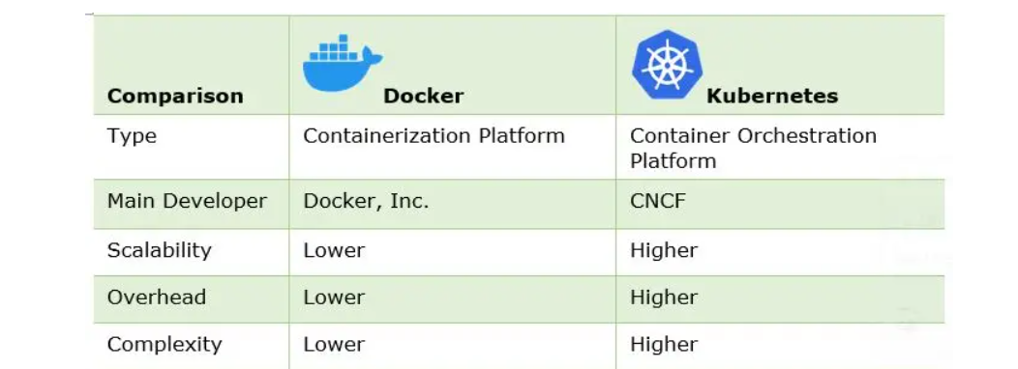

3.diff between container vs pods?

Both are same container called in docker end

Same we can called pod in k8s end

4. .kubernetes hpa ,wt command using scalling pods?

Each HPA exists in the cluster as a HorizontalPodAutoscaler object. To interact with these objects, you can use commands like “kubectl get hpa” or “kubectl describe hpa HPA_NAME”. HPA makes scaling decisions based on resource request values at the container level.

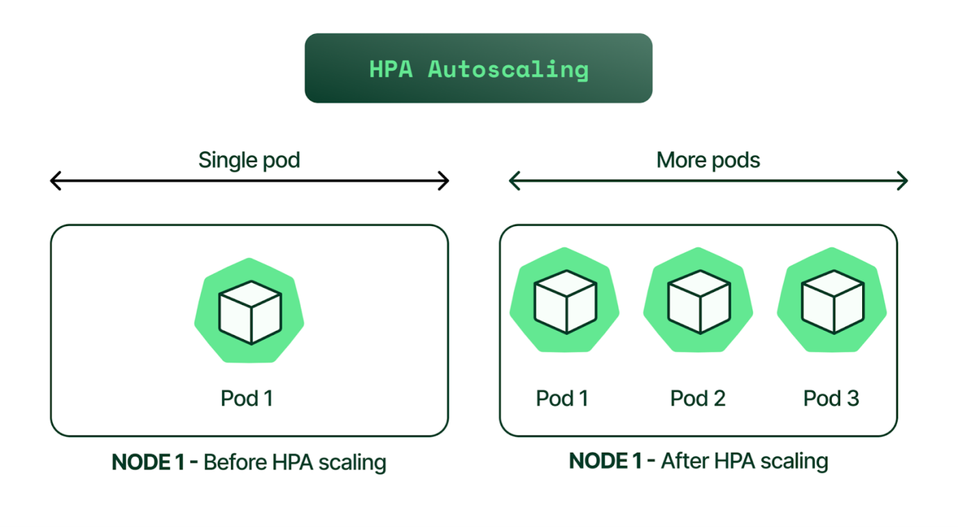

<https://stackoverflow.com/questions/46135670/does-hpahorizontal-pod-autoscaling-considers-the-mean-of-cpu-utilization-of-mu>

<https://www.kubecost.com/kubernetes-autoscaling/kubernetes-hpa/>

5.how to get pods ,wt is command?

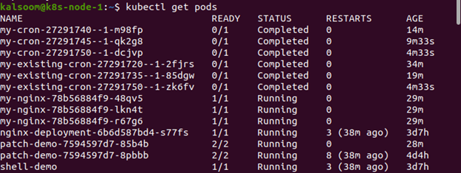

6.how to check namespace, k8s,wt is command

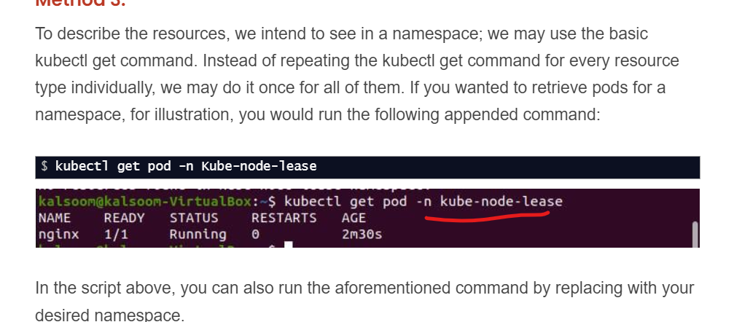

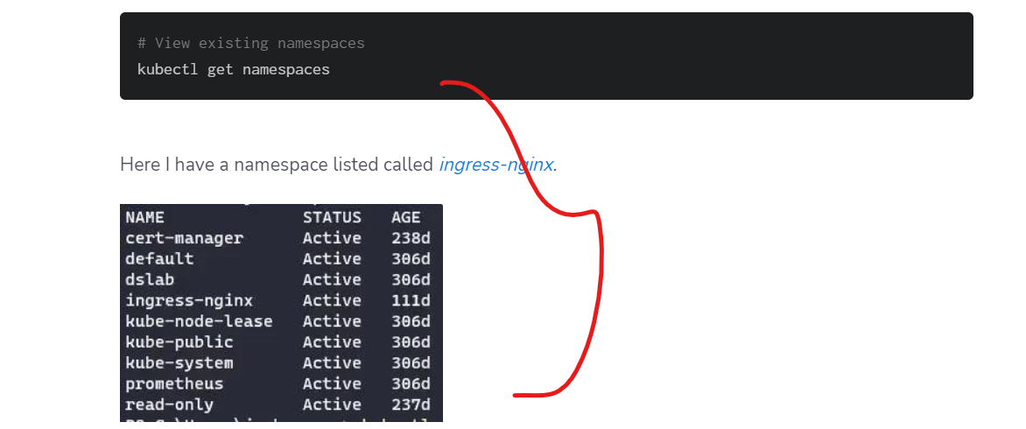

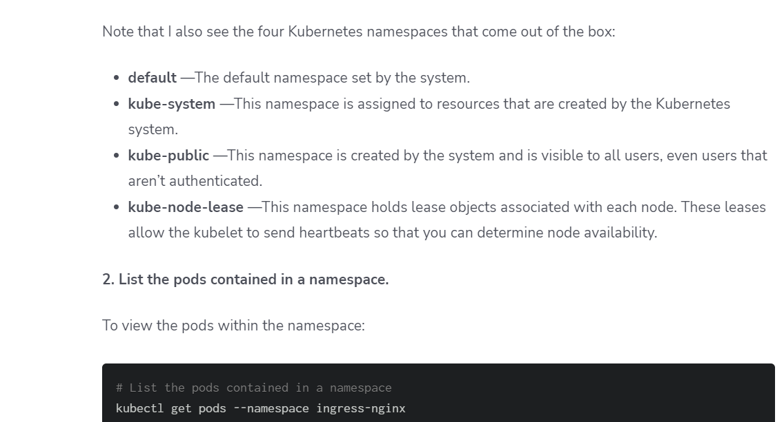

7. .wt is etcd in k8s?

etcd is a consistent and highly-available key value store used as Kubernetes' backing store for all cluster data. If your Kubernetes cluster uses etcd as its backing store, make sure you have a back up plan for the data. You can find in-depth information about etcd in the official documentation

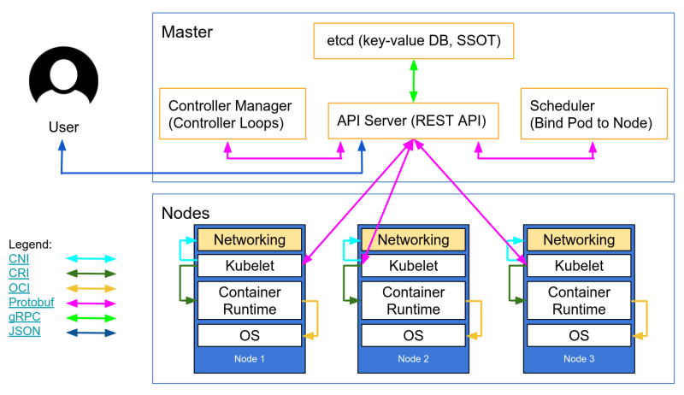

8. wt is deamonset vs statefull set in k8s?

StatefulSets can only be scaled up, scaled down, or deleted. DaemonSets are designed to run one Pod per Node. This ensures that a storage, logging, or monitoring Pod is on every Node. If a Node is added, the DaemonSet will automatically add a Pod to that Node.

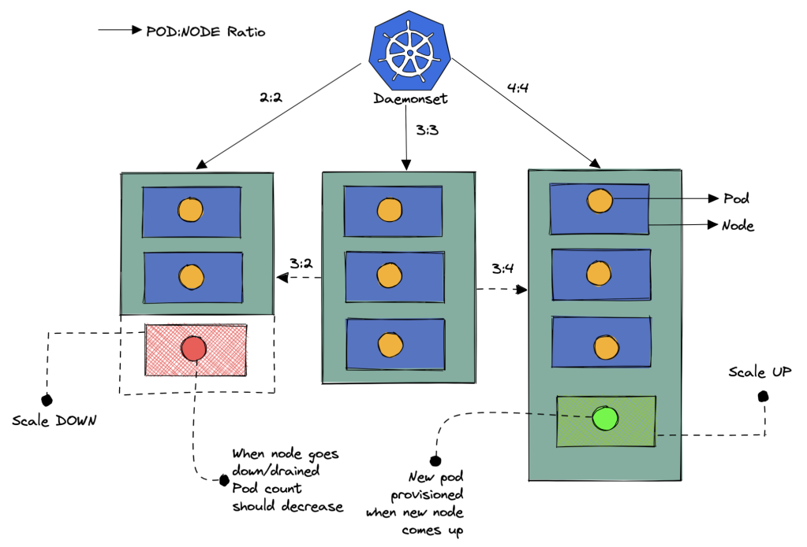

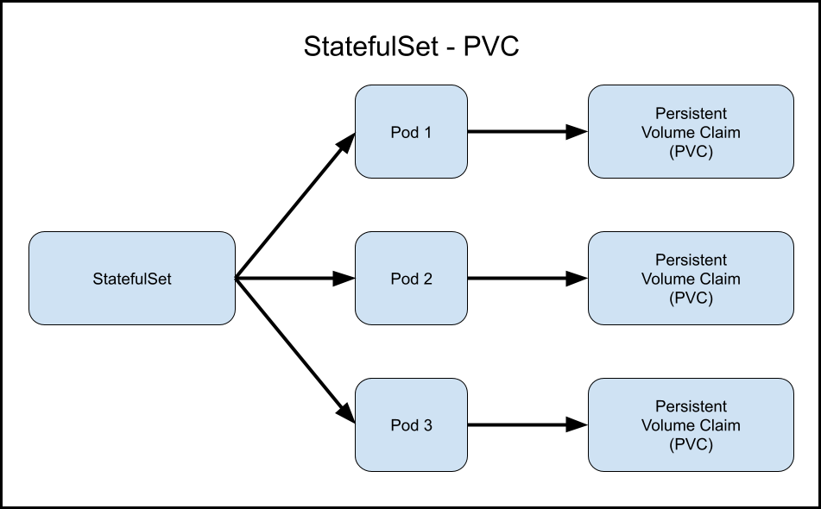

<https://docs.rafay.co/learn/quickstart/kubernetes/deployments-daemonsets-statefulsets/#:~:text=StatefulSets%20can%20only%20be%20scaled%20up%2C%20scaled%20down%2C%20or%20deleted.&text=DaemonSets%20are%20designed%20to%20run,a%20Pod%20to%20that%20Node>.

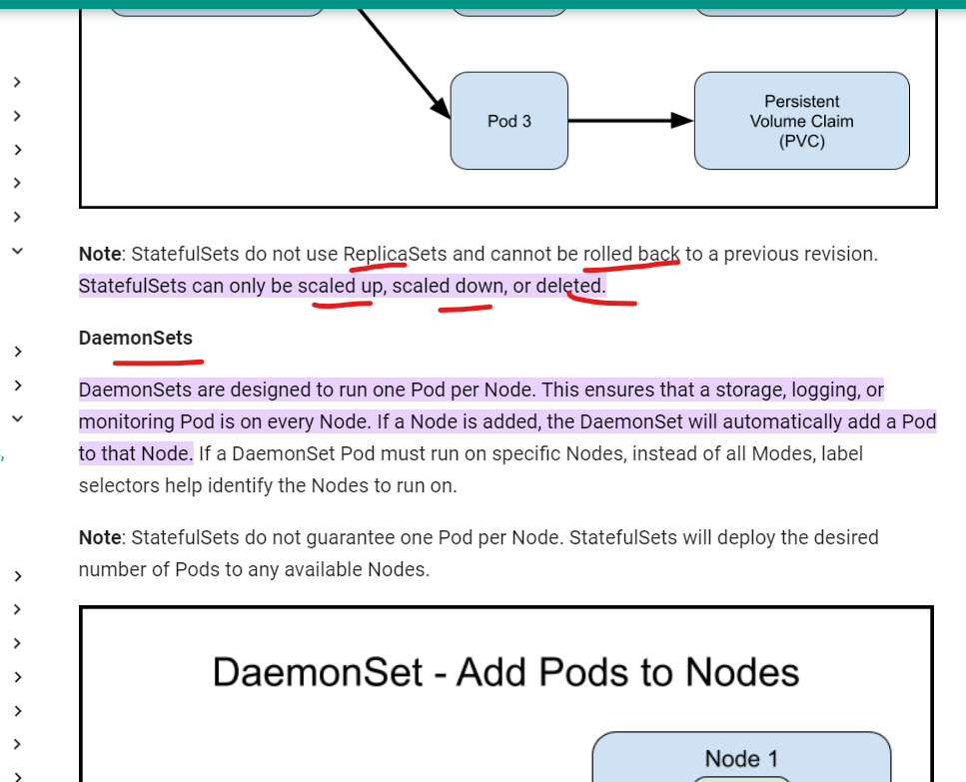

9.wt is pv vs pvc in k8s?

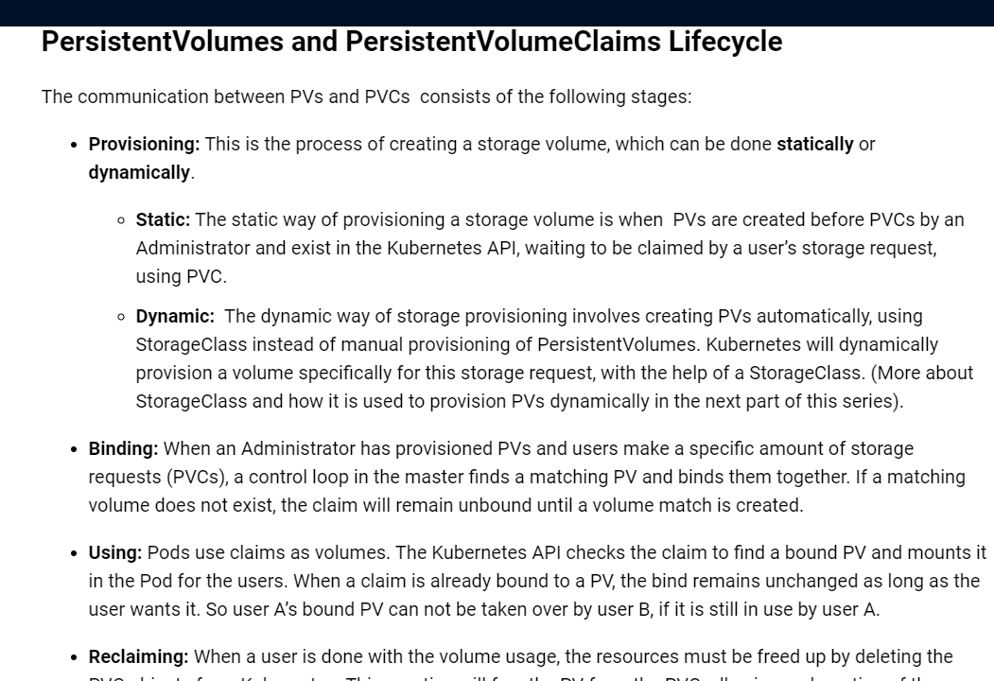

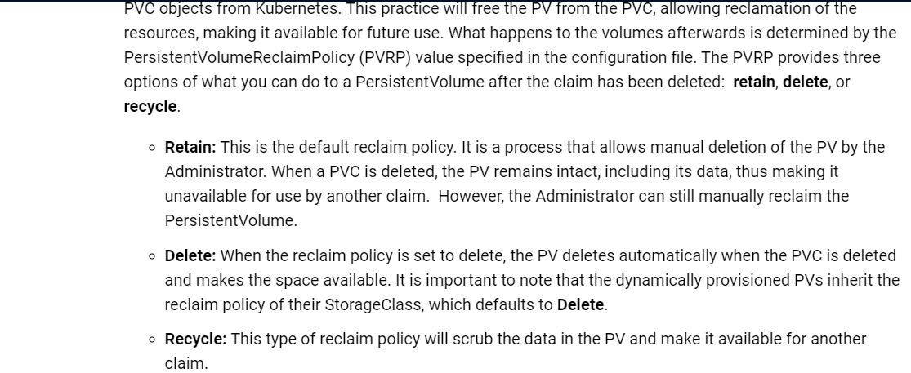

<https://www.kubermatic.com/blog/keeping-the-state-of-apps-4-persistentvolumes-and-persistentvolum/>

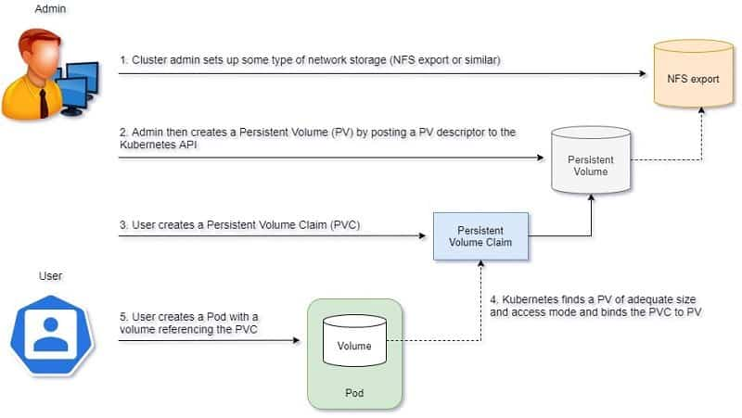

10. wt isconfig map vs secret in k8s?

What is the difference between ConfigMaps and Secrets in Kubernetes? ConfigMaps are used to store non-sensitive configuration data, such as environment variables or configuration files. Secrets, on the other hand, are designed for storing sensitive information like passwords, API keys, or TLS certificates

<https://k21academy.com/docker-kubernetes/configmaps-secrets/#:~:text=What%20is%20the%20difference%20between,API%20keys%2C%20or%20TLS%20certificates>.

11.error occurred while running container then how to edit app configaration file ?how to resolve it in k8s?

12. .if we are getting container crashloop error in k8s? How to resolve it?

<https://medium.com/@darshana.gajbhiye/crashloopbackoff-error-in-kubernetes-what-it-is-and-its-troubleshooting-approaches-cd1db1d17bd5>

imp

<https://collabnix.com/kubernetes-crashloopbackoff-error-what-it-is-and-how-to-fix-it/>

================================

<https://spacelift.io/blog/crashloopbackoff>’

13. how to check listening port in server,wt is command?

Netstat command

14. how to check memory of the server,wt is command?

Free –h

Top

Free -m

15.how to copy file from one server to another?

<https://www.youtube.com/watch?v=hNpXId-SI3Y>

16. how to login private server, which gate ur using in aws?

Create private subnet

Create nat gateway

Then private route table

Attach to nat route in private route table

Then while create machine we are select private subnet

17. wt is diff eip vs public ip?

What is the difference between EIP and public IP?

A Public IP address associated with an instance is not static and is lost when the instance is stopped, whereas an Elastic IP address is a static public address associated with your AWS account.

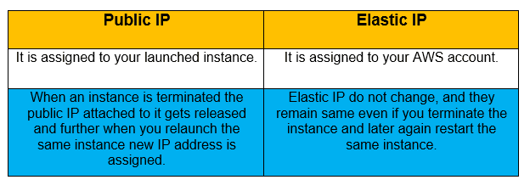

18. how to attach docker volume to container?wt is command

<https://www.geeksforgeeks.org/mounting-a-volume-inside-docker-container/>

19. What is the difference between ingress and load balancer in k8s?

The main difference is ingresses are native objects inside the cluster that can route to multiple services, while load balancers are external to the cluster and only route to a single service.

<https://www.baeldung.com/ops/kubernetes-ingress-vs-load-balancer>

